UNIVERSITY OF GHANA
Department of Computer Science
DCIT 208 – Software Engineering · 2026 Session

IA1

Personal System Request-Flow Diagram
Course Code | DCIT 208 – Software Engineering
Assignment | IA1 – Personal System Request-Flow Diagram
Assignment Title | DCIT208 IA1 – Personal System Request-Flow Diagram
Full Name | Abdulai Abdul-Jaleel Puumaya
Student ID | 22264299
Team Name | InfiniteSystems (SEG26-04)
Project Title | ThreadsOnline — From stock to sale, seamlessly
Client | Alex Tutu
Role | Backend Developer
Chosen Feature | User login/Authentication
Team Repository URL | dcit208-client-project-2026-team-engineering-repository-team
Individual Portfolio URL | https://abdulj1.github.io/
Date | 26 June 2026
Video Link (unlisted YouTube) | [ PASTE YOUR UNLISTED YOUTUBE LINK HERE ]

AI Disclosure Statement: I used AI assistance. The tool, purpose, prompt summary, output accepted/rejected and verification steps are documented in the table below. I understand that I must be able to explain and defend every part of this submission.
AI Usage Disclosure
Date | 26 June 2026
Tool | ChatGPT
Prompt summary | Asked for an explanation of the backend login/authentication process and assistance in creating a request-flow diagram.
Output used | I used ChatGPT to understand the backend login process and create the request-flow. It helped explain HTTPS, JWT, database checks, and JSON responses.
Output rejected | I did not use any answers that did not fit my project. I changed he wording and wrote the final work in my own words.
Verification | I checked the information with our project requirements and made sure it matched our backend tools (Node.js, Express, PostgreSQL, and JWT). I also read through everything to make sure i understood and could explain it.

A. Handwritten Request-Flow Diagram

Feature traced: Backend request flow for user login and authentication in ThreadsOnline.

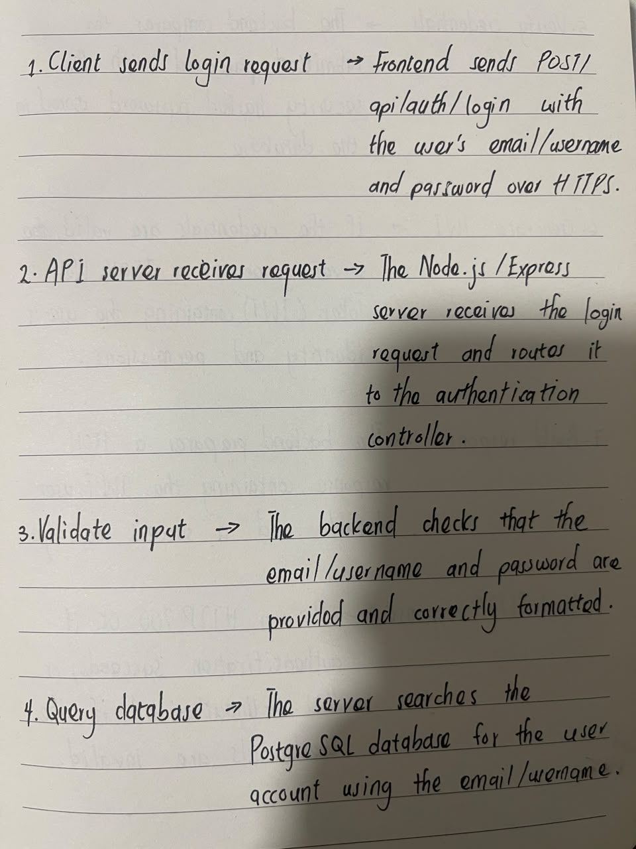

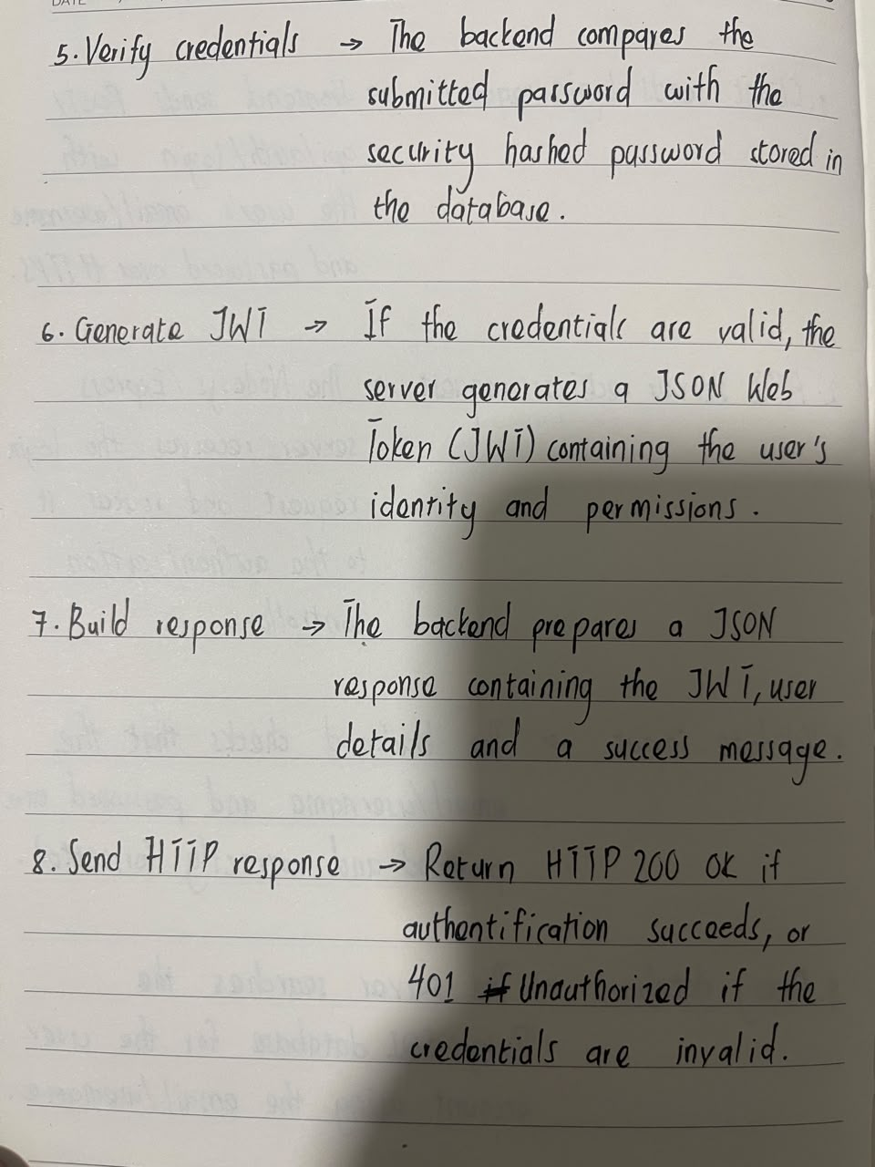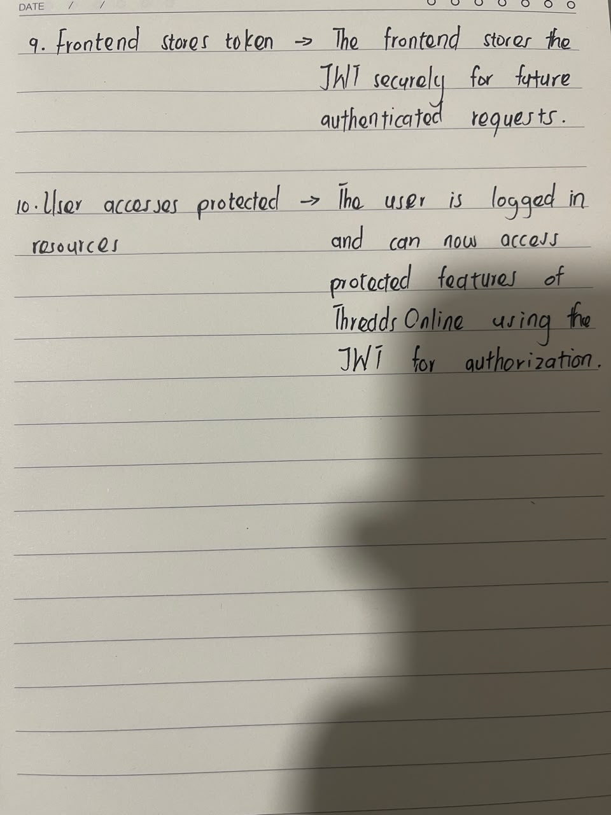

B. Typed Explanation of the Request Flow

The feature I have selected to trace is user login and authentication in ThreadsOnline, the clothing retail web platform my team at InfiniteSystems is building for our client, Alex Tutu. I chose this feature because it is the first step users take before accessing their accounts. It is also important because it protects the users’ personal information and ensures that only registered users can use secure parts of the website.
The request flow starts when the user opens the ThreadsOnline website on a phone or computer. Our team plans to build the frontend using React/Next.js, so users can access the website through a web browser without installing an application.
When the user enters an email address and password and clicks the login button, the frontend sends an HTTPS POST request to the backend at the login endpoint, such as POST /api/auth/login. This is where the login request begins.
The website uses HTTPS to keep the user’s information safe while it is being sent over the internet. HTTPS encrypts the data so that other people cannot easily read the user’s email and password during transmission.
When the request reaches the backend server, the server first checks that the email and password have been entered correctly and that no required information is missing. The server then searches the PostgreSQL database to find the user’s account.
If the account exists, the server compares the password entered by the user with the encrypted password stored in the database using bcrypt. If the passwords match, the user is successfully authenticated. If they do not match, the server returns an error message and the user is asked to try again.
After successful authentication, the backend creates a JSON Web Token (JWT). This token is sent back to the frontend in a JSON response together with a success message and basic user information. The frontend stores the token and includes it in future requests so the user can access protected pages without logging in every time.
If the login is successful, the server returns an HTTP 200 OK response with the JWT and user information. The frontend then redirects the user to their account or dashboard. If the login fails because the email or password is incorrect, the server returns an HTTP 401 Unauthorized response with an error message. The frontend displays the message and allows the user to try again.
If there is a problem with the database or the server is unavailable, the backend returns a server error such as 500 Internal Server Error. The frontend displays a message such as “Something went wrong. Please try again later.” This helps the user know that the problem is with the system and not with their login details.
This request-and-response process shows how the frontend, backend, and database work together to authenticate users securely. Using HTTPS, bcrypt, JWT, PostgreSQL, and JSON responses helps ensure that only authorized users can access their accounts while keeping their information safe.

